An Example of a Properly Formatted Submission to SEFOS
John Doe^{1*}, Max Mustermann¹, and Voyce Ova Ip²
¹Institute of Unknown and Uncharted Sounds, Mare Tranquilitatis, Moon
²Dept. of Connection Failures, Talkative University, Telco, Neverland
*john.doe@uni-moon.edu
This is an example of proper formatting of a contributed paper to SEFOS. The abstract should start with a short summary of the work which will be presented at the seminar. The maximum length of this initial summary is 200 words. The recommended length is about 100 words, i.e. about 1-2 sentences for 'why', 'how', 'wow', and 'what's next'. Please submit your paper until 30th of September to the following email address: submissions@sefos.dk. Please note that this deadline cannot be extended!

Introduction
The following is a template for the submission to SEFOS. All accepted submission will be compiled into an electronic book of abstracts and will also appear on the SEFOS website.
When writing your abstract, please keep in mind that SEFOS will be an interdisciplinary event and that not all readers will be specialists in your topic. Therefore, please always write out the first in-text reference to an acronym or abbreviation that cannot assumed to be common knowledge, and please also spend a few lines more on motivating your question and/or explaining your method if you think that this helps readers of other disciplines understand your line of argument.
Submissions should be made in English. For exceptions (e.g., Danish) please ask the SEFOS organizers.

METHOD
The abstract should be submitted as a PDF document. A maximum of two pages with two columns per page will be considered per submission. A third page may be used for references, appendices, acknowledgements, and/or extra Figures and Tables. Submissions longer than 3 pages will not be accepted! The paper's main text body should be in Times New Roman, 10pt. However, Abstract, Figure captions, Table headings, and entries in the list of references are in 9pt. The font-size may also be smaller in Tables (not smaller than 6pt).
We encourage the use of the MathType plugin for MS Word to include equations into the text. Non-inlined equations are numbered in parenthesis and referred to accordingly. An example is given with Eq. .
Figures should be embedded in the document and labeled Fig. 1, Fig. 2, and so on. Figure captions are entirely in italic. The same applies to Table headings. Please note that bitmapped figures should be inserted in sufficiently high resolution to ensure good printing quality. Authors are free to put all Figures and Tables on abstract's additional third page.
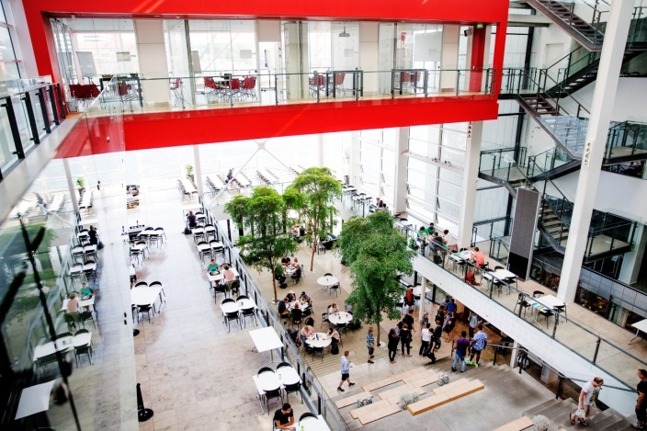
Fig. 1. Spacious venue for poster presentation at SEFOS.

RESULTS
Paragraphs are separated by 6pt spaces. There is no indentation at the beginning of a new paragraph. First-level headings are written in capital letters, preceded by a 12 pt space and followed by a 6 pt space.
Tab. 1: This is a SEFOS table
Variable | Parameter
 | A | B | C
X | AX | BX | CX
Y | AY | BY | CY
Z | AZ | BZ | CZ

Some extra results
Second-level headings should generally be avoided within a short abstract like this. However, if they are required, they have the same formatting as the first-level headings, except that they are not fully written in capital letters (only the initial letter is capitalized in second-level headings).
Please use chronological numbers in square brackets for references in your text [1,2], including URLs [3], and avoid footnotes.
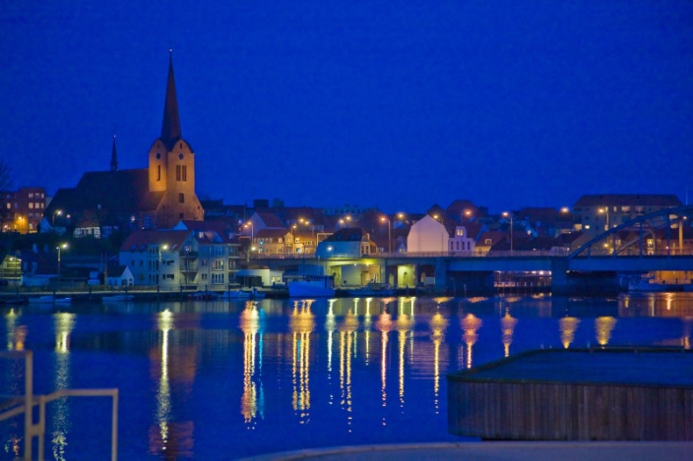
Fig. 2. Sønderborg at night, seen from the university campus, i.e. the SEFOS venue.
Page numbers will be added later to the document electronically. Please add no page numbers to your submitted text.
Please also make sure that all extra symbols (like IPA symbols) are embedded in the text as TrueType fonts (Times New Roman). Ideally, you use the Insert => Symbol ... function in MS Word when adding extra symbols to your text.
In reporting the results of inferential statistics, please make you provide the corresponding test statistics for each p-value, i.e. critical value, degrees of freedom, and a suitable effect-size measure.
The list of references is formatted in APA style. Dissertations are reported like books and papers in proceedings are reported like papers in journals. Please provide DOI numbers where available.

DISCUSSION
We invite contributions on all the various aspects of breathing, pausing, and the voice. Reflecting the cross-disciplinary nature of these fields of research, we are particularly pleased about submissions from the entire speech sciences and beyond, i.e., for example, medicine, rhetoric, technology, music, and zoology. Topics of interest include (but are not limited to):
- acoustic and physiological analyses of speech breathing
- breathing, pausing, and phonation patterns under different mental, emotional, physical conditions
- pathological/clinical aspects of breathing, pausing, and the voice, including pain.
- personality traits (including attractiveness), speaking styles, and their links to breathing, pausing, and the voice
- breathing, pausing, and/or voice patterns in human-machine-interaction and speech technology in general
- interrelations between breathing, pausing, and the voice
- interrelations with other features of prosody, such as F0 and intensity
- silent, fluent, and disfluent pauses, hesitation phenomena
- breathing, pausing and interaction, turn-taking, discourse control
- forms and functions of voice quality in communication
- singing and its relation to phonation and breathing
- new technological or methodological development on the analysis of breathing, pausing, and the voice
- recourses and corpora

Important dates
01st April 2019: SEFOS goes online: registration and submission opens (register already until 30th June and pay a reduced fee of only 90 €!).
30th September 2019: Deadline for the submission of this document.
15th October 2019: Notification of the authors on the acceptance of the submission as either oral presentation or poster presentation.
30th October 2019: Registration closes
01st March – 03rd December 2019: SEFOS.

ACKNOWLEDGMENTS
The authors would like to thank... The presented research was funded by... Note that authors of selected papers will have the opportunity to publish a full paper in a special issue of the International Journal of Linguistics (Acta Linguistica Hafniensia).

REFERENCES
[1] Dewing, T. M., Rossiter, M. J., & Munro, M. J. (2002). Teaching native speakers to listen to foreign-accented speech. Journal of Multilingual and Multicultural Development, 23(4), 245-259.
[2] Thomas, H. K. (2004). Training strategies for improving listeners' comprehension of foreign-accented speech (PhD thesis). University of Colorado, Boulder.
[3] Kraizer, S. (2011). Preventing bullying. Retrieved from http://safechild.org/categoryparents/preventing-bullying/ (accessed mm/dd/yy)

PLEASE NOTE: THIS THIRD PAGE IS RESERVED FOR (ADDITIONAL) REFERENCES, ADDITIONAL FIGURES AND TABLES, APPENDICES, ACK-NOWLEDGMENTS ETC. PLEASE ADD NO FURTHER TEXT NO THIS PAGE!

